Thales' Theorem

Definition
# Source: AI Source: Provided by: [Data Path: Persons Table -> ID Column: 1, Name_En Column: Motasem Essam] -> From: [ChatGPT] on [7/25/2026]
Thales' Theorem states that an angle inscribed in a semicircle is a right angle.
If $A$, $B$, and $C$lie on a circle and $AC$is a diameter, then:
$$\boxed{∠ABC={90}^{∘}}$$
In other words, the angle subtended by a diameter at any point on the circle is a right angle.
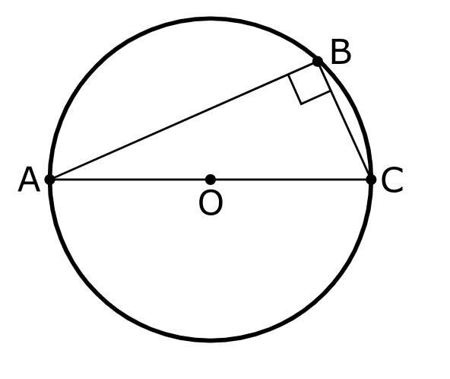
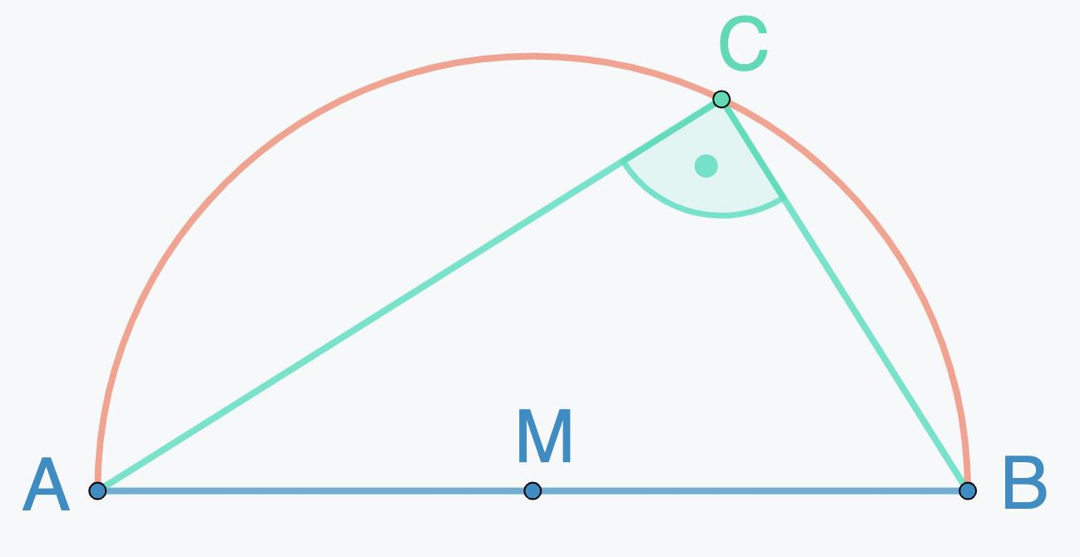
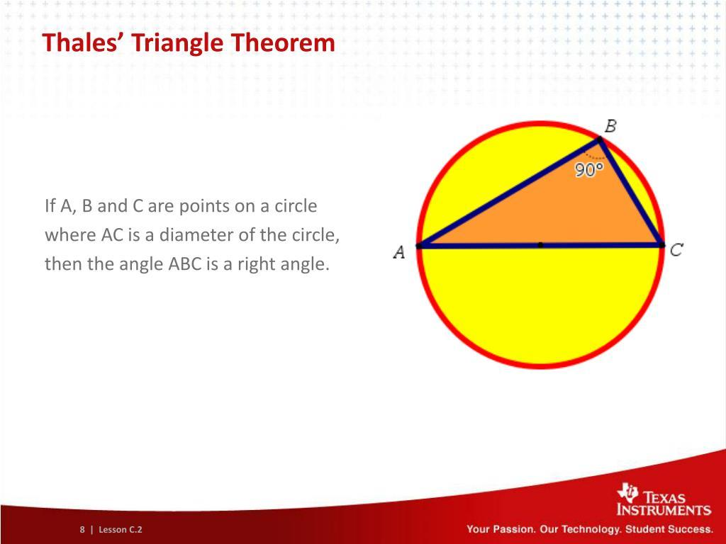
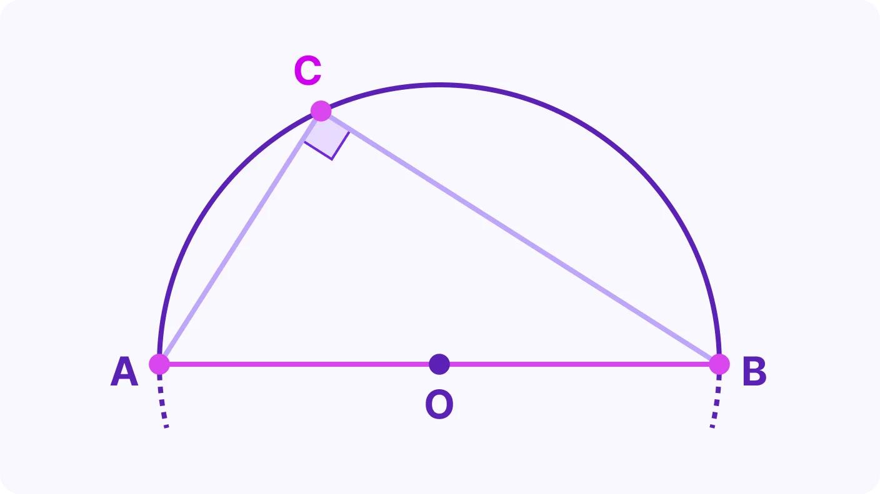

Simple Definition
# Source: AI Source: Provided by: [Data Path: Persons Table -> ID Column: 1, Name_En Column: Motasem Essam] -> From: [ChatGPT] on [7/25/2026]
The angle formed by two lines from any point on a circle to the endpoints of a diameter is always ${90}^{∘}$.

Fundamental Configuration
# Source: AI Source: Provided by: [Data Path: Persons Table -> ID Column: 1, Name_En Column: Motasem Essam] -> From: [ChatGPT] on [7/25/2026]
Consider a circle with center $O$, where $AC$is a diameter and $B$is any other point on the circle.
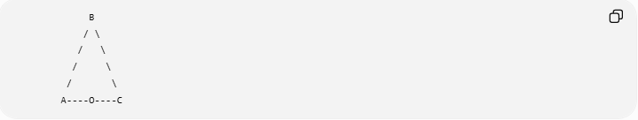
B
/ \
/ \
/ \
/ \
A----O----C
Here:
- $A,B,C$lie on the circle.
- $AC$is a diameter.
- $O$is the center.
- $∠ABC$is an inscribed angle.
- $AC$subtends $∠ABC$.
Therefore:
$$\boxed{∠ABC={90}^{∘}}$$

Mathematical Statement
# Source: AI Source: Provided by: [Data Path: Persons Table -> ID Column: 1, Name_En Column: Motasem Essam] -> From: [ChatGPT] on [7/25/2026]
If $AC$is a diameter of a circle and $B$is any point on the circle other than $A$and $C$, then:
$$\boxed{∠ABC={90}^{∘}}$$
More generally, an inscribed angle is half the measure of its intercepted arc:
$$m∠ABC=\frac{1}{2}m\hat{AC}$$
Since a diameter intercepts a semicircle:
$$m\hat{AC}={180}^{∘}$$
Therefore:
$$m∠ABC=\frac{1}{2}\left({180}^{∘}\right)={90}^{∘}$$

Proof of Thales' Theorem
# Source: AI Source: Provided by: [Data Path: Persons Table -> ID Column: 1, Name_En Column: Motasem Essam] -> From: [ChatGPT] on [7/25/2026]
Let $O$be the center of the circle.
Since $OA$, $OB$, and $OC$are radii:
$$OA=OB=OC$$
Therefore:
- $△AOB$is isosceles.
- $△BOC$is isosceles.
Let:
$$∠ABO=x$$
and
$$∠OBC=y$$
Because $OA=OB$:
$$∠OAB=∠ABO=x$$
Because $OB=OC$:
$$∠OBC=∠BCO=y$$
The angles of $△ABC$are therefore:
$$x+\left(x+y\right)+y={180}^{∘}$$
So:
$$2x+2y={180}^{∘} \\ 2\left(x+y\right)={180}^{∘} \\ x+y={90}^{∘}$$
But:
$$∠ABC=x+y$$
Therefore:
$$\boxed{∠ABC={90}^{∘}}$$

Converse of Thales' Theorem
# Source: AI Source: Provided by: [Data Path: Persons Table -> ID Column: 1, Name_En Column: Motasem Essam] -> From: [ChatGPT] on [7/25/2026]
The theorem also has an important converse:
If an angle subtended by a segment is ${90}^{∘}$, then the endpoint segment is a diameter of the circle through the three points.
Suppose:
$$∠ABC={90}^{∘}$$
and $A,B,C$lie on a circle.
Then:
$$\boxed{AC\text{ is a diameter}}$$
This is commonly called the Converse of Thales' Theorem.

Example 1: Finding an Angle
# Source: AI Source: Provided by: [Data Path: Persons Table -> ID Column: 1, Name_En Column: Motasem Essam] -> From: [ChatGPT] on [7/25/2026]
Suppose $AC$is a diameter of a circle and $B$lies on the circle.
Find:
$$∠ABC$$
By Thales' Theorem:
$$\boxed{∠ABC={90}^{∘}}$$

Example 2: Right Triangle in a Circle
# Source: AI Source: Provided by: [Data Path: Persons Table -> ID Column: 1, Name_En Column: Motasem Essam] -> From: [ChatGPT] on [7/25/2026]
Suppose $AC$is the diameter of a circle and $B$is a point on the circle.
If:
$$AB=6$$
and
$$BC=8$$
then $△ABC$is a right triangle because:
$$∠ABC={90}^{∘}$$
Therefore, by the Pythagorean Theorem:
$$AC^{2}=AB^{2}+BC^{2} \\ AC^{2}=6^{2}+8^{2} \\ AC^{2}=36+64=100 \\ \boxed{AC=10}$$
Thus, the diameter is $10$.

Example 3: Proving a Segment Is a Diameter
# Source: AI Source: Provided by: [Data Path: Persons Table -> ID Column: 1, Name_En Column: Motasem Essam] -> From: [ChatGPT] on [7/25/2026]
Suppose $A,B,C$lie on a circle and:
$$∠ABC={90}^{∘}$$
Because the angle is a right angle, the converse of Thales' Theorem gives:
$$\boxed{AC\text{ is a diameter}}$$

Relationship with Inscribed Angles
# Source: AI Source: Provided by: [Data Path: Persons Table -> ID Column: 1, Name_En Column: Motasem Essam] -> From: [ChatGPT] on [7/25/2026]
Thales' Theorem is a special case of the Inscribed Angle Theorem.
The general theorem is:
$$\boxed{m∠=\frac{1}{2}m\left(\text{intercepted arc}\right)}$$
For a diameter, the intercepted arc is a semicircle:
$${180}^{∘}$$
Therefore:
$$\frac{1}{2}\left({180}^{∘}\right)={90}^{∘}$$
So:
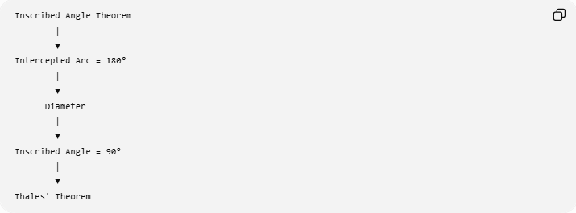
Inscribed Angle Theorem
│
▼
Intercepted Arc = 180°
│
▼
Diameter
│
▼
Inscribed Angle = 90°
│
▼
Thales' Theorem

Why the Point Can Be Anywhere on the Circle
# Source: AI Source: Provided by: [Data Path: Persons Table -> ID Column: 1, Name_En Column: Motasem Essam] -> From: [ChatGPT] on [7/25/2026]
The point $B$can move to different positions on the same semicircle.
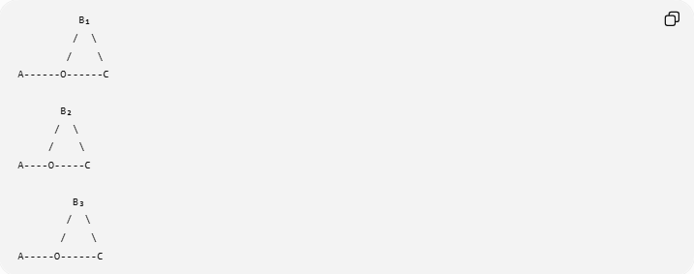
B₁
/ \
/ \
A------O------C

B₂
/ \
/ \
A----O-----C

B₃
/ \
/ \
A-----O------C
As long as $B$remains on the circle and $AC$remains the diameter:
$$\boxed{∠AB_{1}C=∠AB_{2}C=∠AB_{3}C={90}^{∘}}$$
The angle remains constant even though the position of $B$changes.

Important Conditions
# Source: AI Source: Provided by: [Data Path: Persons Table -> ID Column: 1, Name_En Column: Motasem Essam] -> From: [ChatGPT] on [7/25/2026]
Thales' Theorem requires:
- $A,B,C$lie on the same circle.
- $AC$is a diameter.
- $B$lies on the circle.
- The angle being considered is the angle subtended by the diameter.
If $AC$is merely a chord and not a diameter, the angle does not necessarily equal ${90}^{∘}$.

Thales' Theorem vs Converse
# Source: AI Source: Provided by: [Data Path: Persons Table -> ID Column: 1, Name_En Column: Motasem Essam] -> From: [ChatGPT] on [7/25/2026]
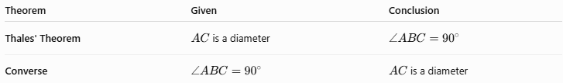
Theorem | Given | Conclusion
Thales' Theorem | $AC$is a diameter | $$∠ABC={90}^{∘}$$
Converse | $$∠ABC={90}^{∘}$$ | $AC$is a diameter
Symbolically:
$$AC\text{ is a diameter}⇒∠ABC={90}^{∘}$$
Converse:
$$∠ABC={90}^{∘}⇒AC\text{ is a diameter}$$

Applications
# Source: AI Source: Provided by: [Data Path: Persons Table -> ID Column: 1, Name_En Column: Motasem Essam] -> From: [ChatGPT] on [7/25/2026]
Thales' Theorem is commonly used to:
- identify right angles in circles;
- prove that a triangle is right-angled;
- identify the diameter of a circle;
- construct right angles;
- solve circle-and-triangle problems;
- apply the Pythagorean Theorem to inscribed triangles;
- prove perpendicular relationships.
Geometric construction connection
A circle can be used to construct a right angle:
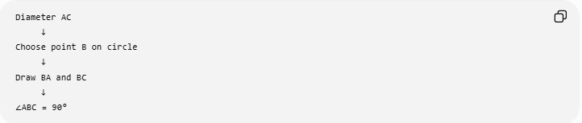
Diameter AC
↓
Choose point B on circle
↓
Draw BA and BC
↓
∠ABC = 90°
Thus, Thales' Theorem provides a geometric method for producing a right angle.

Classification
# Source: AI Source: Provided by: [Data Path: Persons Table -> ID Column: 1, Name_En Column: Motasem Essam] -> From: [ChatGPT] on [7/25/2026]
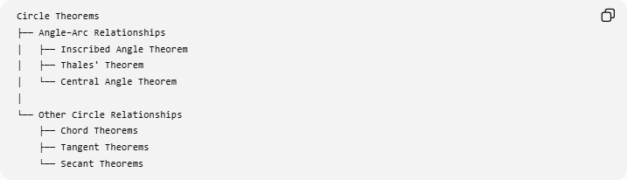
Circle Theorems
├── Angle–Arc Relationships
│ ├── Inscribed Angle Theorem
│ ├── Thales' Theorem
│ └── Central Angle Theorem
│
└── Other Circle Relationships
├── Chord Theorems
├── Tangent Theorems
└── Secant Theorems
Thales' Theorem can specifically be viewed as a special case of the Inscribed Angle Theorem.

Key Points
# Source: AI Source: Provided by: [Data Path: Persons Table -> ID Column: 1, Name_En Column: Motasem Essam] -> From: [ChatGPT] on [7/25/2026]
- Thales' Theorem concerns a diameter and an inscribed angle.
- An angle subtended by a diameter is always:
$$\boxed{{90}^{∘}}$$
- The triangle formed by the diameter and any other point on the circle is a right triangle.
- The converse allows a ${90}^{∘}$inscribed angle to identify a diameter.
- It follows directly from the fact that an inscribed angle measures half its intercepted arc.
- It is especially useful when combining circle geometry with the Pythagorean Theorem.

Conclusion
# Source: AI Source: Provided by: [Data Path: Persons Table -> ID Column: 1, Name_En Column: Motasem Essam] -> From: [ChatGPT] on [7/25/2026]
Thales' Theorem establishes a fundamental connection between circles and right triangles:
$$\boxed{\text{Diameter}⟺\text{90° Inscribed Angle}}$$
More precisely:
$$\boxed{AC\text{ is a diameter}⇒∠ABC={90}^{∘}}$$
and, under the converse conditions,
$$\boxed{∠ABC={90}^{∘}⇒AC\text{ is a diameter}}$$

